**Graph 1:**

Actual Visualization:

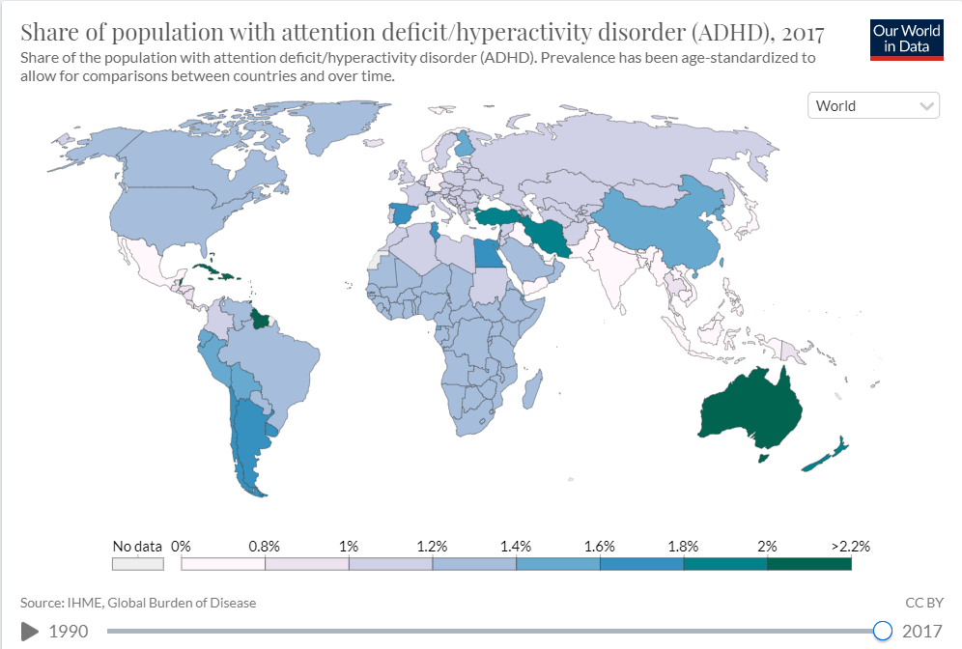

Replicated Visualization:

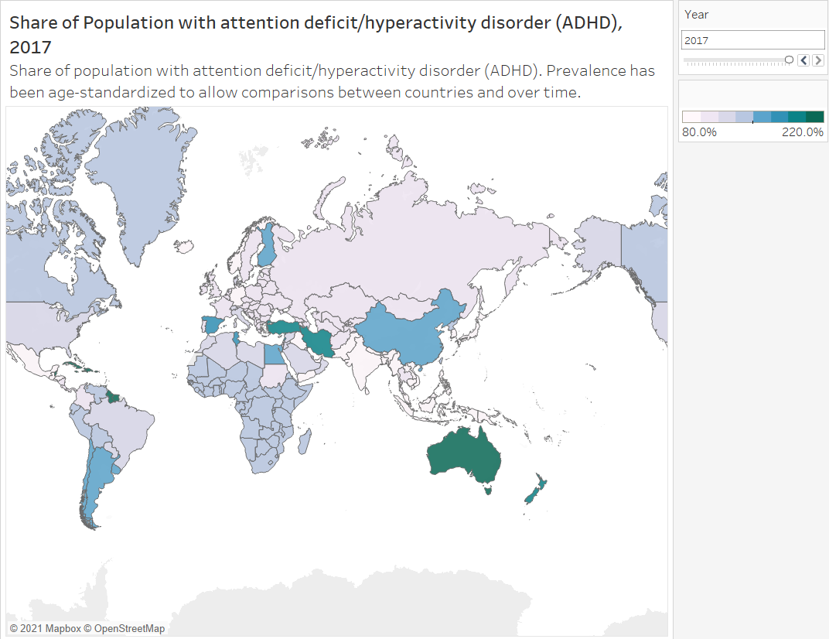

The Map Visualization provides us with a overall share of population with ADHD and how the percentage has changed over the years from 1990 to 2017 worldwide. Furthermore, we can select a country over the map and check for its individual line graph trend that relates to it. (Can be seen in the Dashboard 1 in the tableau file).

**Graph 2:**

Actual Visualization:

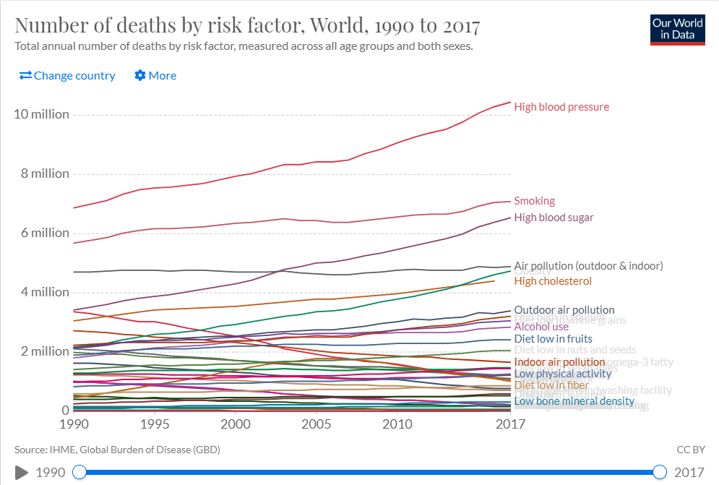

Replicated Visualization:

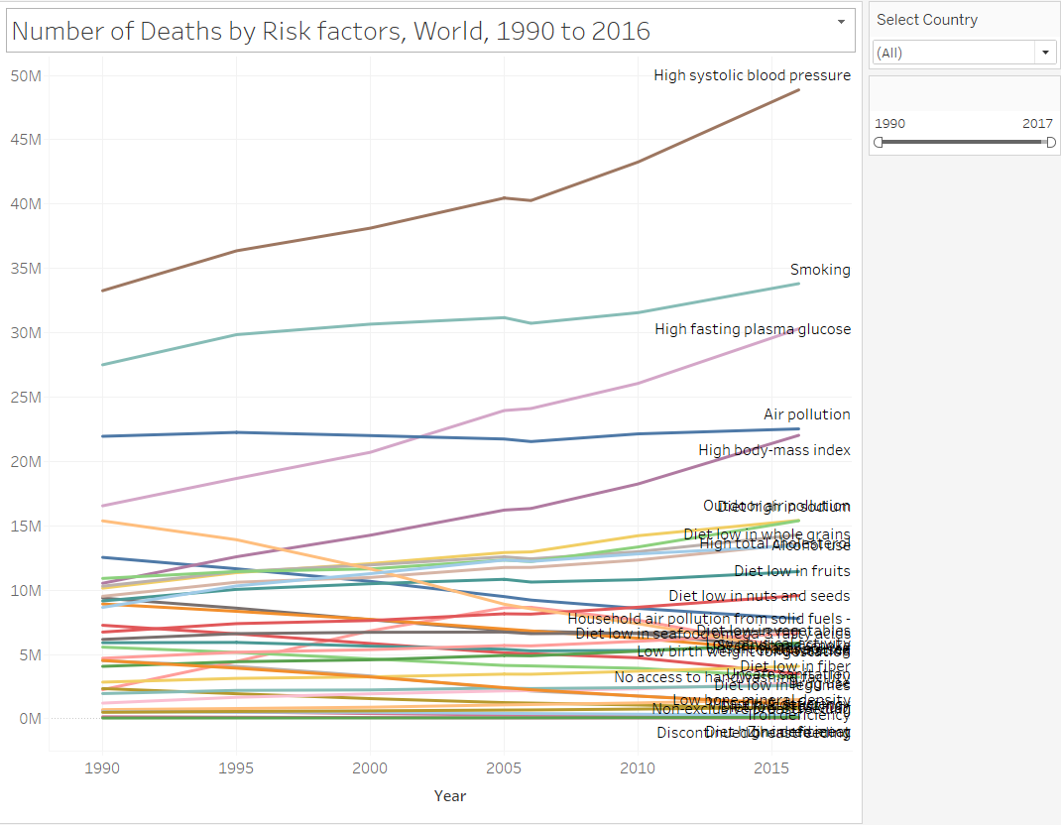

The line chart shows the number of deaths by the multiple risk factors which lead to death. The actual visualization shows the increment on a year basis, while the visualization created sums up the entire deaths of a factor and increments it on a year basis. The visualization is effective as we can see which factor has the highest number of death rates and for which factors there is a standard line, an upward trend or a downward trend. We can also select the time frame and the country we want to see these factors for which helps in visualizing it better if we want to see it on a country basis as well. (The graphs can be seen as Dashboard 2 in the tableau file).

**Graph 3:**

Actual Visualization:

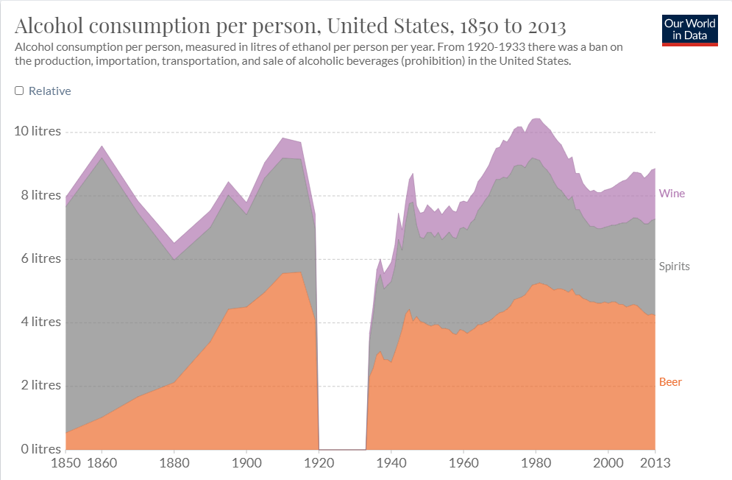

Replicated Visualization:

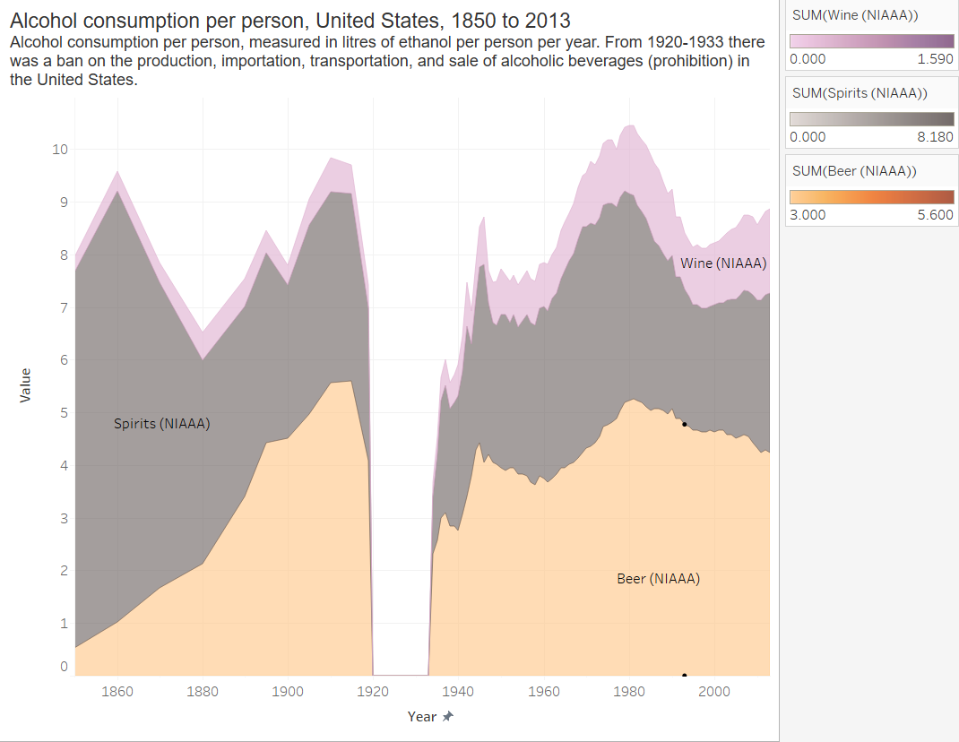

The area graph clearly shows the amount of alcohol that was consumed per person in litres over the years in the United States. From the graph before the 1920-1933 ban there was a clear major consumption of ‘Spirits’ from 1850’s. Wine and Beer consumption was close Zero. However, over the years we can see that the Spirits consumption has dropped down while the Beer consumption increased from the 1880s and has been stagnant after the ban period as well. Wine has not gained much of a boom in the consumption overall, but its consumption has significantly increased from before the ban on Alcohol production.

**Graph 4:**

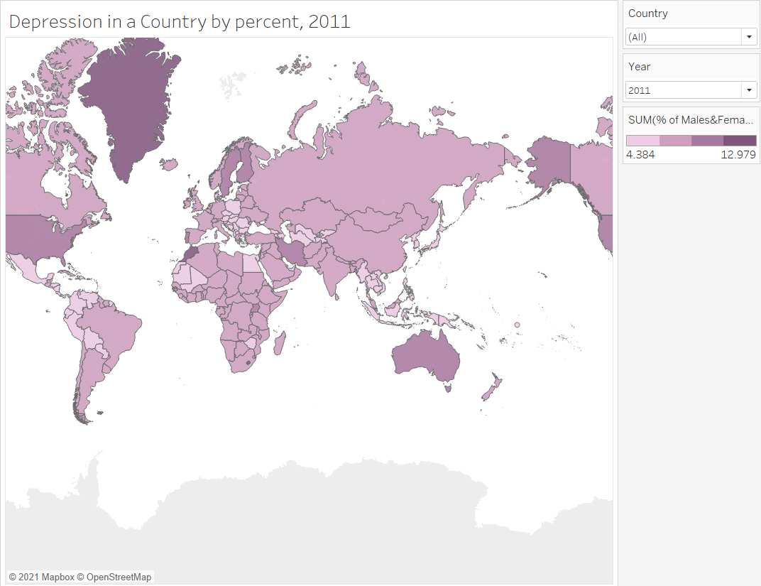

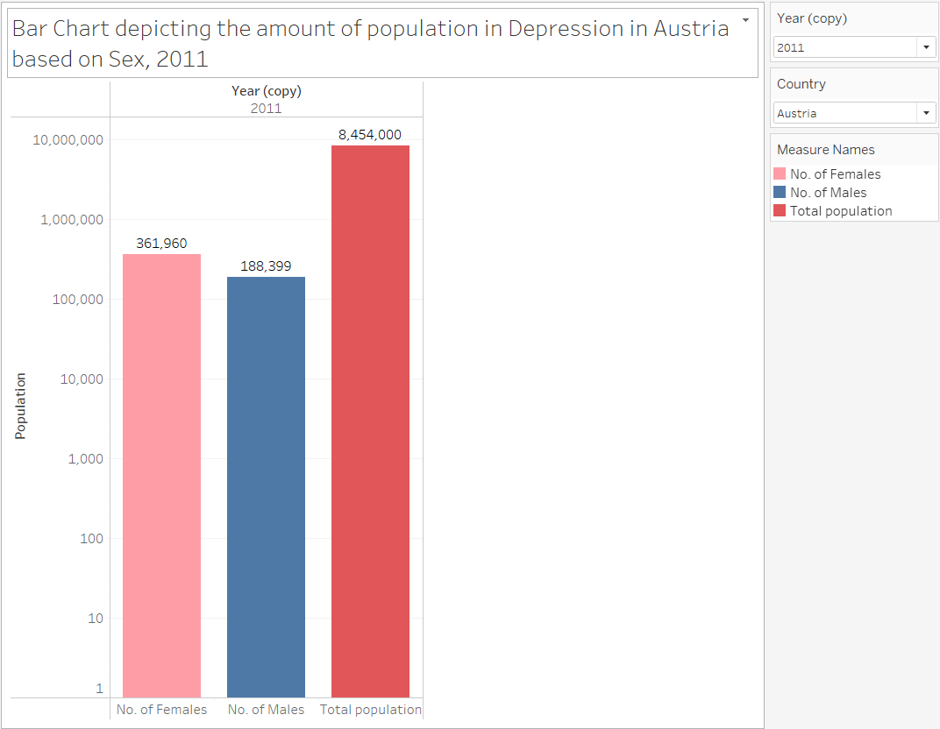

The World Map graph shows the percent of Male and Female population in depression by country for each year from 1990-2018. We can view the world map for each year and for each country as well by selecting the year and the country we wish to have insights on.

In the next graph (side-by-side bars) we can see the number of Males and number of Females of a country in depression against the total population. If we have a look at all the charts for different countries for each year, we can observe that for each country the depression is higher among the females as compared to males. The visualization is simple yet effective to give a clear picture about the no. of males and females in depression against the total population of the country. It also gives a clear picture on the which gender is most affected by depression across the countries.